Digital Service Manual

Contents
- Executive Summary
- What Is a Digital Service?
- About the In-House Digital Team
  - Our Purpose
  - Our Strategy
  - Our Composition and Roles
- How We Prioritize the Services We Build
  - Guiding Principles for Digital Projects
  - Digital Objectives
  - Digital User Groups
- Building a New Digital Service
  - Commissioning a New Digital Service
  - How We Build Digital Services
  - Our Digital Roadmap
- How to Manage Content
  - Getting New Content Approved
  - Style Guides
  - Managing a Social Media Account
  - Home Page Management

1. Executive Summary
This manual provides guidelines for staff members who are either building approved digital services or creating routine digital content.
The manual defines the term digital service; outlines the digital team’s purpose, composition, and roles; summarizes [the organization’s] digital strategy; and explains how we prioritize the services we build.
This document also provides step-by-step instructions for building a new digital service and for getting new content approved.
This is a living document, written by [unit name] with input from across the organization. We welcome your feedback as we continue to refine our approach to digital.

2. What Is a Digital Service?
In this manual, a digital service is a digital tool or combination of tools (such as websites, social media accounts, e-mail lists, and apps) that provides value to users. Digital tools are not inherently useful to the people they are meant to serve. In order to create digital experiences that add value, organizations must build integrated digital services that meet users’ needs and achieve organizational objectives.

3. About the In-House Digital Team

OUR PURPOSE
- To provide effective service to external digital users: The primary role of the core digital team is to improve key audiences’ experiences when they interact with [the organization’s] digital services. The digital team works with employees to identify ways in which we can advance the organization’s strategy by meeting users’ digital needs. The team aims to work in an iterative, data-driven manner in order to build digital services that are effective.
- To provide digital leadership: To help [the organization] use limited resources in an efficient and effective way, the core digital team works with senior managers and teams across the organization to support the strategic priorities of [the organization], including by developing and implementing a digital strategy, digital policies, and digital standards.
- To educate colleagues about digital best practices: The digital team works to educate colleagues about best practices for digital governance, digital tools, and digital approaches so that all staff members can be effective digital ambassadors for the organization.

OUR STRATEGY
The heart of our digital strategy has three parts:
- A clear identification of the challenge
- A guiding policy for solving the challenge
- A set of coherent actions

The challenge
The [organization’s strategy] challenges the organization to [do something]. [The organization] plans to do this by [action 1], [action 2], and [action 3].
From a digital perspective, [the organization] faces a number of challenges in executing the organization’s strategy.
- [Challenge]: [Short description of challenge].
- [Challenge]: [Short description of challenge].
- [Challenge]: [Short description of challenge].

Guiding policies
Note to digital teams: A guiding policy is an overall approach to solving a challenge. Guiding policies direct and constrain employees’ actions but do not specify the actions themselves.
For example, if a large, decentralized organization that has an ad hoc approach to digital needs to decrease costs and improve efficiency, the organization might choose the following guiding principles:
- “Consolidate our digital presence”
- “Standardize our approach to design and development”
- “Modernize our digital governance”
However, these guiding policies involve trade-offs, and they probably would not be right for a small, centralized organization that is facing other more pressing challenges. Choose guiding policies that set a direction that is clear and focused so employees can translate the intent into concrete actions.
To overcome these challenges and fulfill [the organization’s] ambitious strategy, the organization must adopt a new approach to creating and maintaining digital services:
- [Guiding policy]: [Short description of the guiding policy.]
- [Guiding policy]: [Short description of the guiding policy.]
- [Guiding policy]: [Short description of the guiding policy.]
- [Guiding policy]: [Short description of the guiding policy.]

Coherent actions
List the most important actions that the organization should take in order to fulfill the strategy. These actions should be concrete and measurable. They should align with the guiding policies and reinforce each other whenever possible. Don’t try to do everything. Be focused and realistic.
- [Action]: [Short description of the guiding policy.]
- [Action]: [Short description of the guiding policy.]
- [Action]: [Short description of the guiding policy.]
- [Action]: [Short description of the guiding policy.]
- [Action]: [Short description of the guiding policy.]
- [Action]: [Short description of the guiding policy.]

OUR COMPOSITION AND ROLES
A digital team is “the full set of resources required to keep the digital process functioning for your organization.” It includes all internal and external personnel who create, administer, or support digital efforts in some way.
[Unit name] leads the digital team, but [the organization’s] digital capacity is distributed throughout the organization and beyond it.

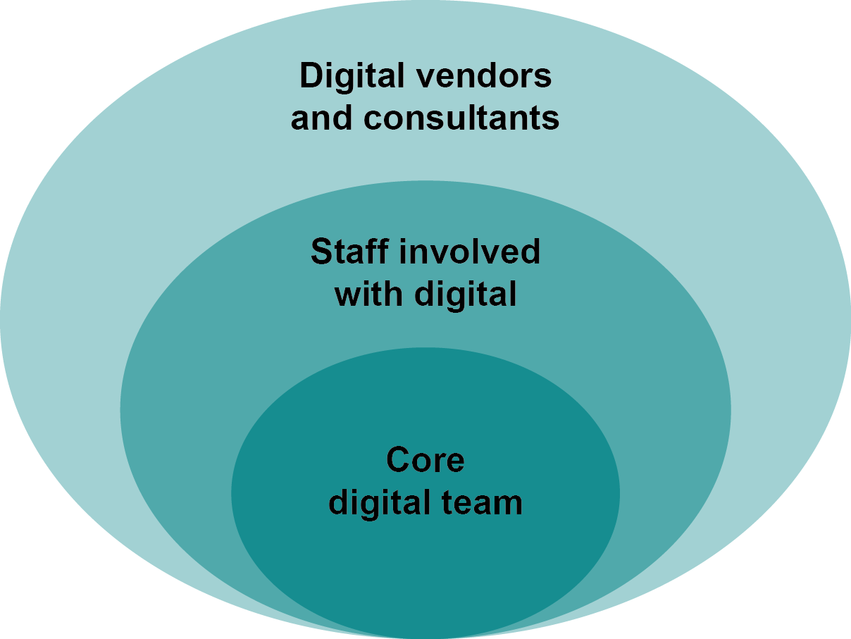

Core digital team: Conceptualizes, plans, and oversees the organization’s digital presence. [The organization’s] core digital team includes the following groups:
- [Unit name]
- [Unit name]
- [Unit name]
- [Unit name]
Staff involved with digital: Maintains the quality of digital properties; provides input for the development of digital standards; and develops and maintains content, applications, or data to support the digital presence in coordination with the core digital team. The distributed digital team includes:
- [Unit name]
- [Unit name]
- [Unit name]
- [Unit name]
Digital vendors & consultants: Provides support to the organization’s digital initiatives by offering products and services that meet short-term or long-term needs. The extended digital team includes the following groups:
- [Type of organization]
- [Type of organization]
- [Type of organization]
- [Type of organization]
- [Type of organization]
- [Type of organization]
[The organization] will [do something] to clarify expectations for people within the core, distributed, and extended digital team. The goal is to [specify which tasks should be centralized and which tasks should be decentralized].

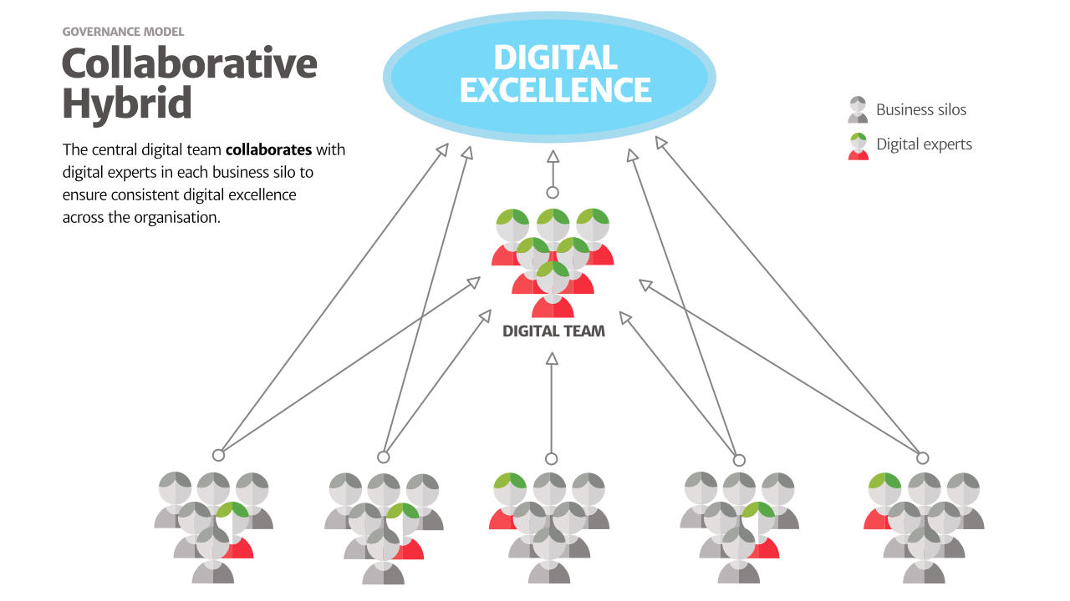

A collaborative hybrid structure might not be appropriate for your organization. Other structures and diagrams are available at Paul Boag’s blog post “Has your organisations’ digital growth become stunted?” https://boagworld.com/digital-strategy/has-your-organisations-digital-growth-become-stunted/.
- Centralized
- Centralized hybrid
- Collaborative hybrid
- Integrated

4. How We Prioritize the Services We Build
Because [the organization] has limited resources and many potential digital projects, the digital team must prioritize which digital services to build and the order in which to build them.
To use our resources in a strategic way, we are prioritizing new projects based on their alignment with our guiding principles for digital, digital objectives, and digital user groups, all of which may evolve as [something happens].

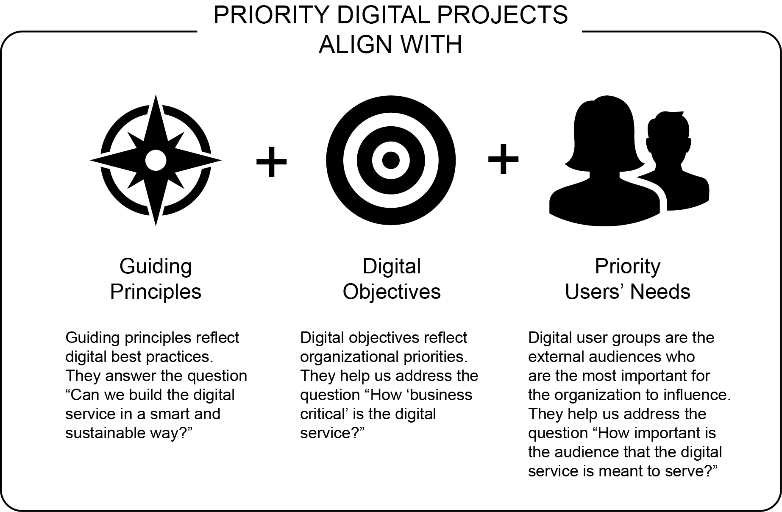

GUIDING PRINCIPLES FOR DIGITAL PROJECTS
To ensure that a digital service is sustainable over the long term and will meet user needs, we have adopted the following guiding principles for digital projects. As we receive new requests for digital improvements, we will ask whether the request aligns with these digital best practices.
For more information about why to create guiding principles (also known as design principles) and seven steps for getting started, see 18F’s Design Principles Guide, https://pages.18f.gov/design-principles-guide/index.html.
- [Guiding principle]
[Short description of the guiding principle]
- [Guiding principle]
[Short description of the guiding principle]
- [Guiding principle]
[Short description of the guiding principle]
- [Guiding principle]
[Short description of the guiding principle]
- [Guiding principle]
[Short description of the guiding principle]
- [Guiding principle]
[Short description of the guiding principle]
- [Guiding principle]
[Short description of the guiding principle]
- [Guiding principle]
[Short description of the guiding principle]
- [Guiding principle]
[Short description of the guiding principle]

DIGITAL OBJECTIVES
Digital objectives help organizations identify which digital services are the best strategic fit for investment. Objectives should be periodically updated as an organization’s priorities evolve.
The following objectives emerged by consensus as a result of numerous research activities (including [list activities here]).
As we receive new requests for digital improvements, we will ask which objectives the request supports. This will help us answer the question “How ‘business critical’ is the request?”

Overall
- [Objective]
- [Objective]
- [Objective]
- [Objective]
- [Objective]

For [name of website, social media channel, or other digital property]
- [Objective]
- [Objective]
- [Objective]

For [name of website, social media channel, or other digital property]
- [Objective]
- [Objective]
- [Objective]

For [name of website, social media channel, or other digital property]
- [Objective]
- [Objective]
- [Objective]

For [name of website, social media channel, or other digital property]
- [Objective]
- [Objective]
- [Objective]

DIGITAL USER GROUPS
Identifying digital user groups helps organizations determine which users are the most important for the organization to influence. The following user groups emerged by consensus as a result of numerous research activities, including [list activities here].
As we receive new requests for digital improvements, we will ask which user groups the request supports. This will help us answer the question “How important is the audience that the digital service is meant to serve?”

Primary
- [User group]
- [User group]

Secondary
- [User group]
- [User group]
- [User group]

5. Building a New Digital Service
To improve the chances that digital projects succeed, we use the following processes for commissioning and building new digital services.

COMMISSIONING A NEW DIGITAL SERVICE
[Insert brief instructions about how teams should propose new digital services.]
Teams should answer the following questions when proposing a new digital service. These questions help to ensure that projects address [the organization’s] and users’ needs in a strategic and sustainable way.
- What is the underlying problem? At the outset of a digital project, it’s tempting to propose a solution and start building it right away. Unfortunately, this often leads to poor results, as teams realize too late in the process that they’ve built the wrong thing. It’s best to begin by developing a shared understanding of the problem (we suggest putting it in writing), so the project team and the digital team can arrive at an appropriate solution together. Often, teams are pleasantly surprised to find that that the best solution is easier and less expensive to implement than first expected.
- Which digital objective does this service address? Teams should identify which of [the organization’s] digital objectives the proposed digital service would support. This helps to answer the question “How ‘business critical’ is the request?” and guides prioritization and project timelines.
- Which user group does the project serve? Teams should identify which of [the organization’s] digital user groups the proposed digital service would support. This helps to answer the question “How important is the audience that the digital service is meant to serve?”
- Can we use an existing platform to solve the challenge? [The organization] has [how many?] digital properties. Is it possible that an existing website, social media account, or e-mail mailing list could meet your needs? The digital team can help identify options for using existing accounts to minimize the burden on staff of creating and maintaining new digital services.
- How will we maintain the digital service? Teams should indicate what resources (human and financial) are available to maintain the digital service after it’s built. Digital services that are out of date or broken can damage [the organization’s] reputation. For example, content needs to be updated and archived, custom code needs to be monitored and tested, and third-party integrations can break without warning.

- How will we assess performance? For proposed new features, the proposing team should create a set of metrics, in consultation with the digital team, for assessing the feature’s performance to guide potential future improvements or for retiring it if it underperforms.

HOW WE BUILD DIGITAL SERVICES
Digital evolves at a rapid rate, and digital users are increasingly demanding. Fortunately, digital is relatively easy to monitor and change—if it’s built with clear objectives and if sufficient resources are available. In fact, digital products and services usually become successful through iteration after the initial launch as organizations learn from their users and experiment with changes.

Making a digital service
After agreeing to create or improve a digital service, we will use the following process to implement the project. The work requires time and attention from both the project team and the digital team throughout the process in order to succeed.
- Discover: During this stage, the project team and the digital team take a closer look at the problem, objectives, users, assets, and constraints. This is a chance to identify assumptions, collect essential information, and create a roadmap.
For large and midsize digital projects, team members should plan for some user research during this stage. Conducting user research ensures that [the organization] can make data-driven decisions about users’ needs. This type of research can be free or inexpensive. A few days of research can dramatically improve the effectiveness of a digital service while saving thousands of dollars.
- Prototype: The next step is to build a prototype. Effective prototypes help teams test the critical elements of a solution before investing in building it. In addition, creating a prototype often raises important questions that are easier to address early in the process, while there is still time to change course.
Prototypes can be simple sketches on paper, advanced digital mockups that are clickable, or something in between. Most prototypes do not need to be complex or expensive. Simpler tends to be better because this allows teams to work faster and make changes sooner.
- Test and Iterate: It’s best to test prototypes with the intended users. Five is a good number of users to recruit during this stage. If it’s not feasible to test the prototype with the intended users, think about who is similar enough to serve as a “proxy” for the user.
Sometimes the prototype works exactly as intended. In those cases, teams can proceed with building the “real” digital service. Other times, testing a prototype reveals some important flaws and possible solutions. When that happens, the project team and the digital team may decide to modify the prototype (or create a new one) and test it with users again.
- Launch: Once a prototype has demonstrated that the project is likely to succeed, team members should build the actual digital service. It’s often best to build in a modular way so you can test components of the new digital service on a rolling basis.
It may also be appropriate to do a soft launch, which involves launching a “beta” version of the service to a subset of the target audience. This gives teams more opportunities to identify and fix issues before issues become entrenched.
Even after a successful launch, it’s often necessary to fix bugs or make changes. Team members and vendors should expect some issues to come up after a launch. They should plan to allocate some time and resources to address postlaunch issues.
- Evolve: Launching a digital service is not the end of the process. Teams should monitor the service’s performance via user feedback, analytics, and other methods.
When components of the service cause significant problems for users or fall short of [the organization’s] expectations, teams should repeat the “Discover > Prototype > Test and Iterate > Launch > Evolve” process for the new improvements. It should be an ongoing, rapid process.
- Retire: Even the best digital services reach retirement as users’ needs and organizational priorities change. This stage should be handled with care. Users may now rely on the service and could be confused if it disappears. Retiring the service could affect other online or offline processes. [The organization] may need to archive content or data from the service and redirect users to a different service.
Teams should expect that digital services will naturally incur these types of costs at the end of the service’s life cycle.

Collaboration is essential
- Joint working relationship: The person who requests the digital service and the digital team share responsibility for ensuring that the digital service achieves organizational objectives and meets users’ needs. It’s the digital team’s responsibility to confirm that organizational objectives and users’ needs are articulated in a clear and practical way before the work begins.
- Level of commitment: Building and maintaining a digital service requires ongoing attention from both the person who requests the digital service and the digital team. Staff should only request new digital services if they can commit to providing timely responses throughout an iterative process. Larger and more expensive projects tend to demand more time and investment from both parties, even when outsourcing the work to a vendor.

OUR DIGITAL ROADMAP FOR [ACHIEVING SOMETHING]
With limited resources and so much potential work, we have to prioritize. What follows is the roadmap we have identified for digital.
We prioritize based on our digital objectives, our overall guiding principles for digital project, and users’ needs.
Timing | Steps | Status
Short term | [Step 1] | [Status]
 | [Step 2] | [Status]
 | [Step 3] | [Status]
Medium term | [Step 4] | [Status]
Long term | [Step 5] | [Status]
 | [Step 6] | [Status]

1. [Name of the step]
[Brief description of step]

Action items
[Month] | [Action item] | [Status]
[Month] | [Action item] | [Status]
[Month] | [Action item] | [Status]

2. [Name of the step]
[Brief description of step]

Action items
[Month] | [Action item] | [Status]
[Month] | [Action item] | [Status]
[Month] | [Action item] | [Status]

3. [Name of the step]
[Brief description of step]

Action items
[Month] | [Action item] | [Status]
[Month] | [Action item] | [Status]
[Month] | [Action item] | [Status]

4. [Name of the step]
[Brief description of step]

Action items
[Month] | [Action item] | [Status]
[Month] | [Action item] | [Status]
[Month] | [Action item] | [Status]

5. [Name of the step]
[Brief description of step]

Action items
[Month] | [Action item] | [Status]
[Month] | [Action item] | [Status]
[Month] | [Action item] | [Status]

6. [Name of the step]
[Brief description of step]

Action items
[Month] | [Action item] | [Status]
[Month] | [Action item] | [Status]
[Month] | [Action item] | [Status]

6. How to Manage Content

GETTING NEW CONTENT APPROVED

Process for publishing content
Please contact [e-mail address] if you are interested in publishing any of the following types of content:
- “Evergreen” content on [website name] (such as [examples of evergreen content])
- “Ephemeral” content on [website name] (such as [examples of ephemeral content])
- Social media posts or links
- Photos, illustrations, infographics, or data visualizations
- Videos
- [Type of content]
- [Type of content]

Steps

Content types on [name of website]
We will use the following guidelines to help ensure that the content we publish serves clear objectives and audiences.

[Name of content type]
[Summarize the purpose and main characteristics of the content type in one or two sentences.]
Rationale:
Objectives:

Audiences:

Tone:

Criteria:
Preference given to content that aligns with multiple criteria:

[Other requirements (e.g., first person vs. third person, reading level, length of paragraphs, requirements about headings, word limits, imagery)]
Information to include:

Calls to action:

Ways to promote it:

Metrics:

Workflow:

[Name of content type]
[Summarize the purpose and main characteristics of the content type in one or two sentences.]
Rationale:
Objectives:

Audiences:

Tone:

Criteria:
Preference given to content that aligns with multiple criteria:

[Other requirements (e.g., first person vs. third person, reading level, length of paragraphs, requirements about headings, word limits, imagery)]
Information to include:

Calls to action:

Ways to promote it:

Metrics:

Workflow:

[Name of content type]
[Summarize the purpose and main characteristics of the content type in one or two sentences.]
Rationale:
Objectives:

Audiences:

Tone:

Criteria:
Preference given to content that aligns with multiple criteria:

[Other requirements (e.g., first person vs. third person, reading level, length of paragraphs, requirements about headings, word limits, imagery)]
Information to include:

Calls to action:

Ways to promote it:

Metrics:

Workflow:

STYLE GUIDES
Organizations should aim to present themselves in a relatively consistent way online and offline. This conveys professionalism and builds trust with audiences while reinforcing the organization’s identity. We adhere to the guidance in the following resources to promote consistency:

For editorial matters
First consult [name of the primary style guide].
For additional questions, contact [e-mail address] or the latest edition of [name of the back-up style guide (e.g., AP, Chicago Manual of Style, APA].
For additional questions about spelling, use the latest edition of [dictionary’s name].

For branding and design
When designing materials for external publication, consult [name of brand manual] for instructions about using [the organization’s] logo, fonts, colors, and other brand elements.
Templates and other brand assets are available at [link to repository].
- [Template/asset name]
- [Template/asset name]
- [Template/asset name]
- [Template/asset name]
- [Template/asset name]
- [Template/asset name]
- [Template/asset name]
We understand that it’s sometimes necessary to create a new template or modify an existing template. In those cases, please contact us at [e-mail address]. We will work with you to develop a solution that is consistent with [the organization’s] brand.

MANAGING A SOCIAL MEDIA ACCOUNT

Before launching a new social media account
Managing a social media account on behalf of an organization is a big responsibility. Teams are often surprised by the amount of time and resources that it takes to keep a social media channel up to date.
[Insert brief instructions about how teams should propose a new social media account.]
Your proposal should answer the following questions:
- Why should the channel exist? Please specify the channel’s objective. What would be the purpose of the account, why is this type of social media a good fit. Why doesn’t an existing channel meet the need?
- Who is the audience? Be specific when defining your audience. Once you know who you want to reach, determine to what extent your audience is active on social media. Is your audience interacting with other users on this type of social media, or is your audience just posting its own content on autopilot, without reading the types of content that you want to share?
- Does [the organization] already have a similar channel? [The organization] has [number] digital properties. Is it possible that an existing social media account, e-mail mailing list, or website could meet your needs? The digital team can help identify options for using existing accounts to minimize the burden on staff of creating and maintaining new accounts.
- Does your team have enough time and content? Some social media channels require more time than others, but nearly all of them require a steady stream of daily updates in order to attract and retain an audience. How much time do you have available to brainstorm ideas for content, create and approve the content, publish the content, monitor the account’s performance, respond to comments, and interact in other ways with community members on the platform? How long will you maintain the account, and will you still have time to maintain it as your responsibilities evolve at [the organization]?
- Who will run the account? Managing a social media account on behalf of an organization is more complicated than managing a personal account. Is the account’s designated team member aware of best practices for social? Does this person have experience with managing social media on behalf of an organization? Is this person knowledgeable about [the organization] and our audiences? Is this person genuinely interested in managing the account, and does this person possess the public relations skills to represent [the organization]?
- Who will run the account when that person is unavailable? Will a team member be available to maintain the channel when you are out of the office? How much will you expect this person to do in your absence, and what support will you provide? How many other team members will have access to the account?

Best practices for social media
Social media platforms and practices evolve at a rapid rate, but a number of best practices have emerged for managing social media channels. Here are a few:

- Set objectives and define audiences: Create objectives that specify what you want to achieve. Decide which audiences you will target. Put your objectives and target audiences in writing, and ensure that your team members have the same understanding about your approach.
- Listen and adapt: Before you open a social media account, spend some time on the platform listening to conversations that are relevant to your objectives and audiences. Make a list of insights about community members’ topics of conversation, types of interactions, popular posts, prominent users, and community norms. As you begin sharing your own content and engaging with other users, monitor the account’s analytics. Be prepared to adjust your objectives and tactics based on what you learn.
- Be a “good guest” at the party: At a party, people will avoid you if you talk only about yourself. Social media is the same way. Share a mix of your own content and other users’ content. Before sharing something, ask yourself whether your audience would be genuinely interested in reading it. Remember that your account is associated with [the organization], so only share content that aligns with [the organization’s] values. Follow other users, and respond to their questions and comments. Avoid using social media to “blast” your content at other users or to hijack their conversations. If you’re not sure whether a certain tactic would be perceived as spam, you should find a different tactic or reconsider your overall approach.
- Create an editorial calendar: In a spreadsheet, Word document, or calendar template, make a note of important dates (e.g., holidays, internationally observed dates, [organization] events, project milestones). Decide what content you will share on which dates. Then work backward to determine when to create this content. If more than one person is responsible for the account, specify who will handle each task. You should aim to share a steady stream of relevant content, but quality is more important than quantity.
- Define community standards and uphold them: Establish some basic rules of conduct. The rules may not always prevent users from engaging in abusive behavior, but they will allow you to specify the consequences. See this example of community standards. Banning or blocking users should be done only as a last resort; however, if a user continually breaks the rules, you have every right to ban or block the user. If you have questions about how to handle inappropriate comments or difficult users, please contact [e-mail address].

See the gov.uk team’s “Social Media Playbook” for more best practices and advice about social media.

HOME PAGE MANAGEMENT
Because there are limitations on user attention, we must be strategic about which content to display on the home page. The quantity and type of content is based on user research, industry standards for usability, and the strategically selected messages we want all of our audiences to hear.
Our home page has [description of the home page’s main sections and brief explanation about the purpose of each one].
Although we all like to see our own team’s content on the home page, the home page is not as important as you might think. During [the previous year], traffic to our home page accounted for just [percentage] of the site’s overall page views. With the rise of social media, more users are skipping the home page altogether by following links that lead directly to websites’ subpages. Nowadays, every page is page 1.
When selecting content for the home page, we will give priority to content that aligns with multiple criteria:

Changing the home page’s structure is possible, but it requires time, resources, and validation. Before making a structural change, we will use proven research methods such as A/B testing and usability testing to confirm that the change improves outcomes for [the organization] and users.

This three-part framework comes from Richard P. Rumelt, Good Strategy / Bad Strategy: The Difference and Why It Matters (New York: Crown Business, 2011).
Lisa Welchman, Managing Chaos: Digital Governance by Design (New York: Rosenfeld Media, 2015), 31.
Adapted from various sources, including the "Principles for Digital Development", the "Design Principles" by the UK's Government Digital Service, and the “US Digital Services Playbook.”

